Task 1: LCD Interface

- Print text on the LCD display
- Scroll text on the LCD display
- Accept serial input and display it on the LCD
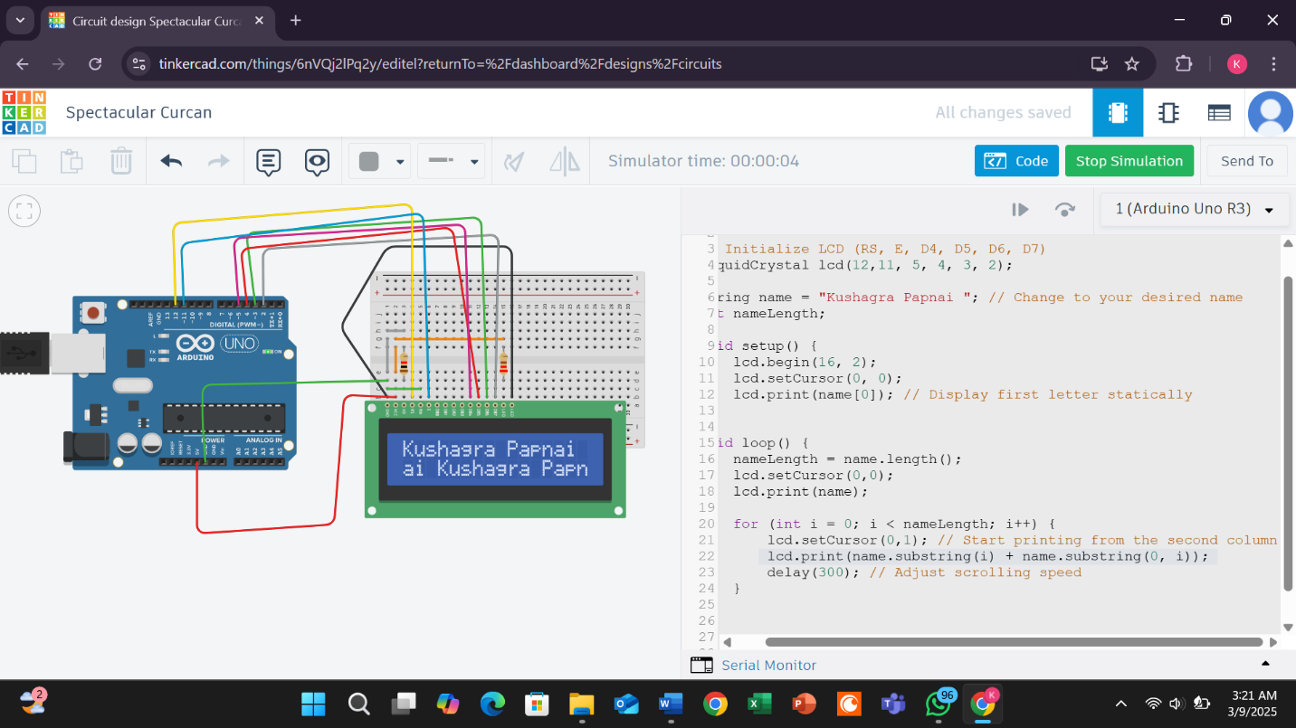

#include <LiquidCrystal.h>

// Initialize LCD (RS, E, D4, D5, D6, D7)
LiquidCrystal lcd(12,11, 5, 4, 3, 2);

String name = "Kushagra Papnai "; // Change to your desired name
int nameLength;

void setup() {
lcd.begin(16, 2);
lcd.setCursor(0, 0);
lcd.print(name); //
}

void loop() {
nameLength = name.length();
for (int i = 0; i < nameLength; i++) {
lcd.setCursor(0,1); // Start printing from the second column
lcd.print(name.substring(i) + name.substring(0, i));
delay(300); // Adjust scrolling speed
}
}

